Concept
EC (SIO) aur PCH do alag IC hain.
- EC (SIO) = House Manager (Power Button, Keyboard, Fan, Battery...)
- PCH = Main Controller (CPU, RAM, PCIe, USB...)
Laptop ON karne ke liye dono ka aapas me "baat karna" zaruri hai.

Step 1 : Adapter Connect
+3VALW
+3VRTC
+RTCVCC
EC aur PCH dono ko standby power milti hai.
Lekin dono abhi fully ON nahi hue.

Step 2 : PCH RTC Start
RTC Crystal
│
▼
PCH RTC
│
▼
SUSCLK
│
▼
EC
SUSCLK kya karta hai?
Ye PCH bolta hai
"Main zinda hoon."
EC ko timing reference mil jata hai.

Step 3 : EC Ready
EC ke paas
- Supply
- Reset
- Clock
- BIOS
sab aa gaya.
Ab EC firmware execute karta hai.

Step 4 : Power Button
Power Button
│
▼
EC Detect
User ne Power Button dabaya.
EC samajh gaya.

Step 5 : EC PCH ko Request bhejta hai
EC bolta hai
Please Laptop ON karo
PCH request receive karta hai.

Step 6 : PCH Ready hai ya nahi?
Agar PCH Ready hai
to
RSMRST#
Release karega.
Ye signal bolta hai
"Main Reset se bahar aa gaya."

Step 7 : Sleep Signals
Fir PCH ek-ek karke release karta hai
SLP_S5#
│
▼

SLP_S4#
│
▼

SLP_S3#
Har signal ek naya regulator ON karta hai.

Step 8 : PCH Reset
PCH khud bhi reset se bahar aata hai.
Aur dusre devices ko bhi reset release karta hai.

Poora Communication
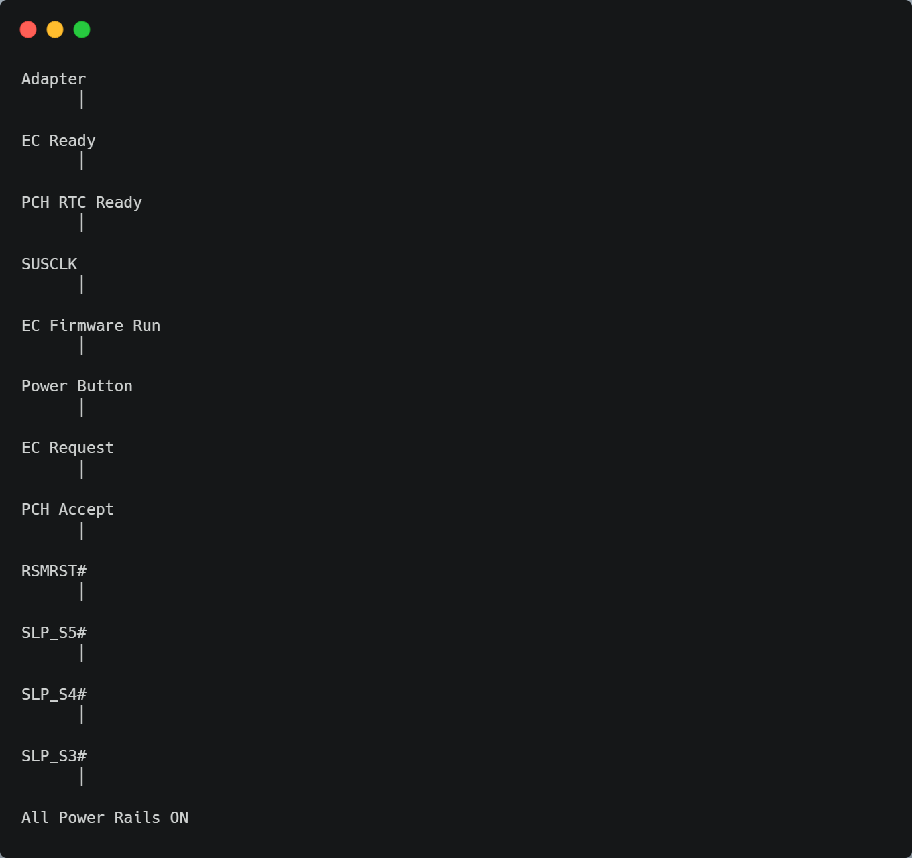
Ab samajhiye har signal ka matlab
1. SUSCLK
PCH → EC
Meaning
Main Ready hoon.

2. RSMRST#
PCH → EC
Meaning
Main Standby Reset se bahar aa gaya.

3. SLP_S5#
PCH → Motherboard
Meaning
Soft OFF khatam.
Power Sequence Start.

4. SLP_S4#
Meaning
Hibernate se bahar.
Aur regulators ON.

5. SLP_S3#
Meaning
Sleep khatam.
Ab System ON ki taraf jao.
Repairing Point
Isliye hum ye signals check karte hain:
✅ SUSCLK hai?
↓
✅ RSMRST# High hai?
↓
✅ SLP_S5# Release hua?
↓
✅ SLP_S4# Release hua?
↓
✅ SLP_S3# Release hua?
Agar chain kisi ek signal par ruk gayi, to usi point ke aage ki power sequence bhi ruk jayegi.
EC–PCH Handshake & Power Sequence Confirmation"
"EC ↔ PCH Communication Confirmation"
• SUSCLK, RSMRST#, SLP_S5#, SLP_S4#, SLP_S3# zyadatar PCH → EC/Board ke outputs hote hain.
• EC se PCH ki taraf PWRBTN#, SMI#, SCI#, KBC signals jaate hain.

Note:
Purane Intel Platforms (ICH / HM Series)
Kai purane Intel boards me:
EC
│
RSMRST#
│
▼
PCH
Yahan EC RSMRST# release karta hai, jisse PCH standby reset se bahar aata hai.
Isliye aapne jo padha hai, wo galat nahi hai.

Naye Intel Platforms (8th Gen+, Tiger Lake, Alder Lake...)
Aksar sequence aisa hota hai:
RTC Power
│
▼
PCH
│
▼
RSMRST#
│
▼
EC aur baaki circuits
Yahan PCH RSMRST# control karta hai.

RSMRST# ki direction assume mat karo.
Hamesha schematic dekho.
- Agar net EC pin se output hai → EC → PCH
- Agar net PCH pin se output hai → PCH → EC/Board

Aapke Notes ke liye

Main is point ko aise likhunga:
RSMRST#
Purpose:
Standby Reset Signal.
Ye signal PCH ko ya PCH se generate ho sakta hai
(board/platform dependent).

Iska kaam Standby Mode se Power Sequence ko start karna hai.

Direction hamesha schematic se confirm karein.

